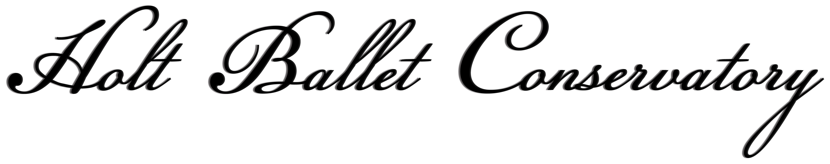

Registration Fall 2016
Name of Student __________________________________________________________________________________________________________________________

Person responsible for payment: ______________________________________________________________________________________________________

Home phone______________________________________________________Cell____________________________________________________________________
Date of Birth: ____________________________________________________________(age) ___________________________________________

Year In school: _____________________________________

Street Address_________________________________________________________ City ____________________________________Zip______________________

Email _______________________________________________________________________________________________________________

EmergencyContact/Relationship__________________________________________________________________Phone#___________________________

Class Enrollment: Month Please check appropriate blanks
1 class per week per Term/month $45.00 $________________________________________________

2 classes per week per Term/month $85.00 $_________________________________________________

3 classes per week per Term/month $125.00 $_________________________________________________

4 classes per week per Term/month $155.00 $________________________________________________

5 classes per week per Term/month $185.00 $_________________________________________________

6 classes per week per Term/month $210.00 $_________________________________________________

7 classes per week per Term/month $238.00 $_________________________________________________

8 classes per week/month $265.00 $________________________________________________

9 classes per week/month $288.00 $_________________________________________________

Drop in (one class) $ 15.00 $________________________________________________

Registration (annual) $30.00 /individual or $45/family $_______________________________________________________
Total $_________________________________________________________

Check classes enrolling in:

Pre Ballet Monday ________ IA Mon ___________1B Wed __________ IIA Fri _________IIB Tues
IIB Thurs _________II/III Mon _________ III Tues __________III Thurs _________III/IV Wed _________IV Fri ___________

Holt Ballet Conservatory, Student Information, Liability Waiver, and Policies Acknowledgment
Please sign below:

I have voluntarily chosen to participate in the dance training offered by Ballet Conservatory and acknowledge that I am under no obligation to continue such dance training. I am aware that dance training and related activities carry certain risks that can result in injury, both minor and major. By my participation in dance classes and activities at The Nevada City Odd Fellows Hall, I agree to take full responsibility for not exceeding my limits, for selecting the appropriate level class and for any injury I might suffer. Furthermore, I am aware that Holt Ballet Conservatory and its instructors have the right to ask me to attend another level class if they believe I could cause harm to myself or others participating in activities above my capabilities. I understand that instructors may provide physical adjustments during class and that this is an integral part of proper dance training.

In consideration of the opportunity afforded me to participate in the dance training offered at The Nevada City Odd Fellows Hall, I, on behalf of myself and heirs, guardians, personal representatives, or assigns, do hereby release, waive, discharge, and covenant not to sue Holt Ballet Conservatory, its instructors, or The Nevada City Odd Fellows Hall from any and all costs, losses, damages, liabilities or claims (including without limitation arising from the negligence of any of the instructors, directors, staff, agents, officers, or representatives of Holt Ballet Conservatory resulting in personal injury, accidents, illnesses {including death} or property loss) which may accrue to me in connection with any activity whatsoever at the above stated locations.

I further expressly agree that the foregoing liability waiver is intended to be as broad and inclusive as its permitted by the law of the State of California and that if any portion thereof is held invalid, it is agreed that the remainder of the agreement shall, notwithstanding, continue in full legal force and effect.

I have read the foregoing liability waiver, fully understand its terms, and understand that I am giving up substantial rights, including my right to sue. This agreement is freely and voluntarily executed.

By signing below, I further understand and acknowledge: that Holt Ballet Conservatory has the right to refuse services and classes to any individual at anytime.

Signature:____________________________________________________________________________________
(If over 18; otherwise parent or legal guardian must sign and is bound to minor and terms.)

Date:_________________________________________________________________________________________

I, the undersigned, realize that photographs of myself or my child dancing, may be used by Holt Ballet Conservatory for marketing and promotions.

Signature: ___________________________________________________________________________________

Date: _________________________________________________________________________________________

